Dear Parents / guardians,
BeaTz Dance Academy is delighted to announce the first ever Inter Dance School competition is taking place this winter. This is a Fun filled day making all children feel confident and amazing.

The competition will be on SATURDAY 29th NOVEMBER 2025 at Parmiters School, Sports Hall, High Elms lane, Garston. WD25 0UU.

Dancers need to arrive promptly at 2:30pm in full costume, hair and make-up done. The competition starts promptly at 3:15pm. Children will be required to be there for the whole duration. The day will finish at approximately 5:30/6pm. At least 1 adult (18+) is required to stay with the dancer all day.

Upon arriving at Parmiters School we will be in the SPORTS HALL. This is a separate entrance to the school building. The sports hall entrance is next to the sporting fields. If you come off the A405 to High Elm Lane it’s your first right turn into Parmiters after West Herts crematorium.

To participate in the competition, we are asking for a compulsory £45.00 per child. This covers 1 costume and entry for the day for the dancer performing & up to 4 family members. If your child is in more than 1 dance it will be an additional £15 per class on top of the £45.00. (e.g. 1 class attending £45.00, 2 classes attending £60.00)

If you’d like more than 4 spectators to attend please email us so we can let you know if we have space for the capacity nearer the day.

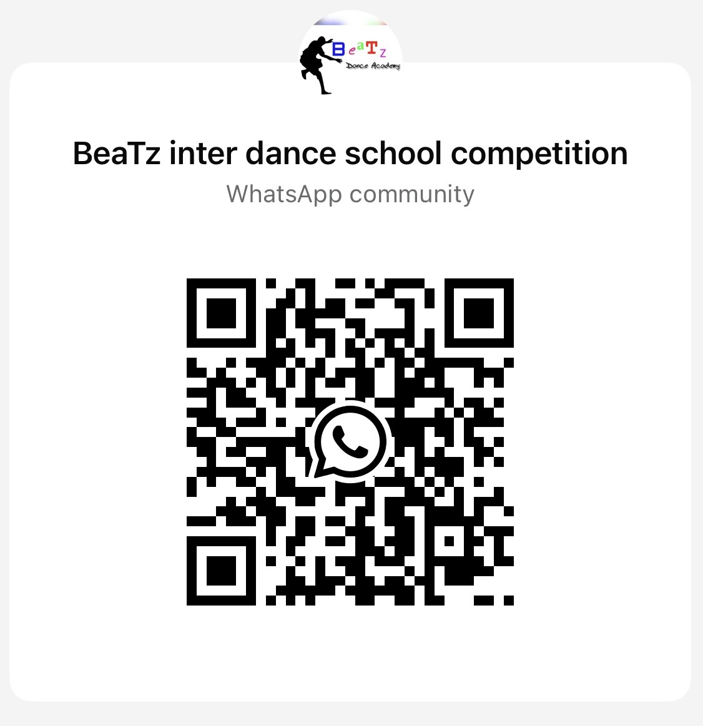
PLEASE USE QR CODE TO JOIN THE WHATSAPP COMMUNITITY. ALL INFO WILL BE POSTED HERE, IF YOU’RE NOT PART OF IT YOU MAY MISS CRUTIAL INFORMATION FOR THE DAY.

ALL DANCERS WILL RECEIVE A MEDAL AT THE END OF THE DAY & CERTIFICATES FOR 1ST, 2ND & 3RD PLACED DANCES.

All dancers will perform their dance they are learning within their dance class they attend with BeaTz & a full dance school opening routine

We have an optional FREESTYLE category for children to enter. There will be 2 groups; 8 and under, 9 and over.
The freestyle song will be chosen for each category and announced online on Monday 29th September. To enter the freestyle is FREE of charge, children can ‘Freestyle’ on the day or pre plan their moves. Entries must be notified no later than 1st NOVEMBER.

*PLEASE GO TO OUR WEBSITE TO SEE WHAT YOUR CHILD IS TO WEAR ON THE SHOW DAY FOR THEIR DANCE THIS WILL BE UP LATEST 18TH OCTOBER, you will be required to supply footwear and possibly an additional item.
*COME WITH HAIR & STAGE MAKE UP DONE. SUPPLY CHILD WITH OWN IF TOUCH UP WILL BE REQUIRED.
ALL THE INFORMATION WILL ALSO BE POSTED IN THE WHATSAPP COMMUNITY FOR THE DANCE COMPETITION SO PLEASE JOIN. See QR code on the reply slip at the bottom

DEADLINE 18TH OCTOBER!!!!!

ANY SLIPS HANDED IN AFTER 18th OCTOBER PARENTS MAY NEED TO ORDER THE OUTFIT THEMSELVES OR WE HOLD THE RIGHT TO NOT ALLOW ANY ADDITIONAL CHILDREN TO JOIN

Each dancer can have up to 4 spectators watch them and be around on the day, if you’d like more please email us.

There will be a refreshments stall on the day but feel free to bring along your own drinks & snacks
NO NUTS PLEASE!!

CASH ONLY FOR REFRESHMENTS & STALLS ON THE DAY. Please bring small change if possible

- COSTUMES (PLEASE LOOK AT OUR WEBSITE FOR THESE DETAILS; under THE BOOKING FORM “COMPETITION INFORMATION”- www.beatzdanceacademy.co.uk)
- Dancers & spectators Can only have rubber soled shoes. No bare feet or high heels. Trainers or plimsolls advised for dancers.

Due to restricted parking spaces the venue kindly asks that we keep vehicles to 1 per dancer where possible. There are 100 spaces available on the day for venue parking. There is also road parking outside the venue or an over flown car park in a separate entrance for Parmiters school further down High Elm Lane.

We have a professional photographer there on the day, Individual or group photo options. These are priced accordingly by ‘Photograph my event’ and the accept card and cash payments.

Many Thanks
BeaTz Dance Academy
T:07815 666 748 / E:cassi_beatz@hotmail.co.uk
www.beatzdanceacademy.co.uk

FAQ:

Does my child need to wear make up? No, make up is optional

Can staff look after my child who is dancing? At least 1, 18+ adult must chaperone their child all day

Can my child leave after their dance? Yes your child can, however they will miss the medal and award ceremony at the end of the day

Is there food available on the day? There will be cold drinks, snacks and refreshments available on the day

Can I pay by card at the event? It will be cash only for the day

Is there anywhere to sit down? The hall will be marked out for dance groups to set up camp. Floor sitting available and you can bring your own camping chairs.

Saturday 29th November 2025- BeaTz Dance Academy Inter school competition
Please fill out 1 per child if you have multiple children performing

Childs Name:

Dance class/group/school Name:

Medical Conditions:

Contact numbers for show day (please provide 2):

PLEASE USE QR CODE TO JOIN THE WHATSAPP COMMUNITITY. ALL INFO WILL BE POSTED HERE, IF YOU’RE NOT PART OF IT YOU MAY MISS CRUTIAL INFORMATION FOR THE DAY.

Dancer fee (costume & spectators): BACS ONLY (childs name as reference) SC:20-91-79/ACC no:33855406

CHILDS CLOTHING SIZE: Age 5-6 / 7-8 / 9-11 / 12-13 Adult S / M / L - Please circle one

ENTERING FREESTYLE: 8 & under YES / NO 9 & Over YES / NO

Signature of consent to attend the full day of SATURDAY 29th NOVEMBER 2025:

Photo/ video consent for the Show & Promotion: YES / NO
We have a professional photographer there on the day.

Parents comments:

